SIMATS ENGINEERING
ASSESSMENT TOOL 2
COURSE NAME: Database Management Systems
COURSE CODE: CSA0504
COURSE OUTCOME COVERED
CO3: Analyze relational databases using functional dependencies, normalization (1NF to 5NF), and key constraints to identify redundancy and ensure data integrity. (BL2, BL3)
Activity Tool : Case Study (Medium)
Assessment Tool Weightage: 30%
QUESTIONS Total Marks: 50
Q.No | Question | Bloom's Level | Marks
1 | Analyze the case: An online shopping platform stores  Order(OrderID, CustID, CustName, ProdID, ProdName, Qty, Price).  Identify FDs and normalize to 3NF. | BL2 – Understand | 5
2 | A hospital maintains Patient(PID, PName, DocID, DocName, Specialization, WardNo, WardName). Identify anomalies and normalize to BCNF. | BL3 – Apply | 5
3 | Case study: A university stores Enrollment(SID, SName, CourseID, CourseName, Faculty, Grade). Analyze FDs and apply 2NF decomposition. | BL3 – Apply | 5
4 | Given the airline booking case: Booking(FlightNo, PassID,  PassName, Seat, DeptCity, ArrCity, Date). Normalize up to BCNF. | BL3 – Apply | 5
5 | Analyze an HR system schema for a multinational company. Identify all functional and transitive dependencies and normalize to 3NF. | BL2 – Understand | 5
6 | Case: Library(MemberID, MemberName, BookID, Title, Author, Genre, BorrowDate). Identify MVDs and decompose to 4NF. | BL3 – Apply | 5
7 | Analyze a telecom billing schema and identify all candidate keys, primary keys, and functional dependencies before normalization. | BL2 – Understand | 5
8 | A retail inventory system has Product(PID, PName, SupplierID, SupplierName, Category, Price, Warehouse). Apply complete normalization. | BL3 – Apply | 5
9 | Study the given poorly normalized schema for a School ERP and propose a fully normalized design up to BCNF with justification. | BL3 – Apply | 5
10 | Given a movie streaming platform schema, identify join dependencies and decompose to 5NF with lossless-join verification. | BL3 – Apply | 5
Criteria | Level 4 –  Exemplary | Level 3 –  Proficient | Level 2 –  Developing | Level 1 –  Beginning
Understandin g of Case | Thorough understanding  ; clearly identifies all key issues | Good understanding with most issues identified | Basic understanding  ; some issues missed | Poor understanding  ; problem not identified correctly
Application of Concepts | Effectively applies  relevant  concepts to analyze the case deeply | Applies appropriate  concepts with minor gaps | Limited application of concepts | Fails to apply relevant concepts
Analysis | In-depth analysis with strong  reasoning and insights | Good analysis with logical reasoning | Basic analysis with limited depth | Weak or no analysis; lacks reasoning
Solution Design | Innovative, feasible  solutions with strong | Logical solutions with adequate justification | Basic solutions with weak justification | Incorrect or no solution provided
Code of Conduct:
I A.Rakesh(192525388) (Name / Reg No) certify that this submission is my original work and that I have adhered to the guidelines specified for this assessment. I understand that any violation of academic integrity rules will result in disciplinary action.
Signature of the student:A.Rakesh

Question 1
Online shopping platform - Normalize Order to 3NF

Given Relation
Order(OrderID, CustID, CustName, ProdID, ProdName, Qty, Price)

Step 1 - Functional Dependencies Identified
- OrderID -> CustID
- CustID -> CustName
- ProdID -> ProdName, Price
- (OrderID, ProdID) -> Qty

Candidate Key
Candidate key = (OrderID, ProdID), since one order can contain many products and Qty is specific to an order-product combination.

Anomalies in the Given Relation
- Insertion anomaly: a new product cannot be added to the catalog until it is part of an order.
- Update anomaly: if a customer's name changes, every order row for that customer must be updated.
- Deletion anomaly: deleting the only order of a customer erases that customer's details entirely.

Step 2 - Normalization
1NF
All attributes already hold atomic (single) values, so the relation is in 1NF.
2NF
The key is composite (OrderID, ProdID). CustID and CustName depend only on OrderID (part of the key), and ProdName/Price depend only on ProdID (part of the key) - these are partial dependencies, which 2NF disallows.
Remove the partial dependencies into their own relations.

3NF
After the 2NF split, Customer(CustID -> CustName) and Product(ProdID -> ProdName, Price) each have a single-attribute key with no transitive dependency left, so the design is already in 3NF.

Final Normalized Schema
Customer(CustID, CustName)
Product(ProdID, ProdName, Price)
Orders(OrderID, CustID) -- FK CustID -> Customer
OrderDetails(OrderID, ProdID, Qty) -- FK OrderID -> Orders, FK ProdID -> Product

SQL Output (executed result)
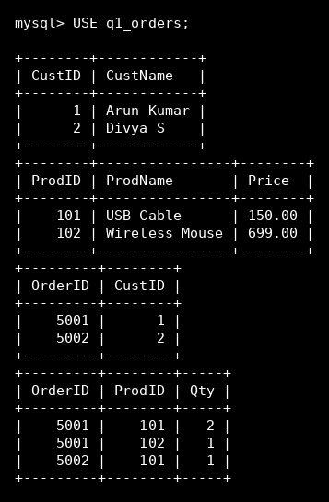
Question 2
Hospital system - Anomalies and normalize Patient to BCNF

Given Relation
Patient(PID, PName, DocID, DocName, Specialization, WardNo, WardName)

Step 1 - Functional Dependencies Identified
- PID -> PName, DocID, WardNo
- DocID -> DocName, Specialization
- WardNo -> WardName

Candidate Key
Candidate key = PID.

Anomalies in the Given Relation
- Update anomaly: changing a doctor's specialization requires updating every patient row treated by that doctor.
- Insertion anomaly: a newly joined doctor cannot be recorded until assigned at least one patient.
- Deletion anomaly: discharging the last patient in a ward deletes the ward's name from the database.

Step 2 - Normalization
1NF -> 2NF -> 3NF
All attributes are atomic and depend fully on the single-attribute key PID, so the relation already satisfies 1NF, 2NF and 3NF.
BCNF check
BCNF requires every determinant to be a candidate key.
DocID -> DocName, Specialization: DocID is a determinant but not a candidate key of Patient - violates BCNF.
WardNo -> WardName: WardNo is a determinant but not a candidate key of Patient - violates BCNF.
Decompose to remove both violations.

Final Normalized Schema
Doctor(DocID, DocName, Specialization)
Ward(WardNo, WardName)
Patient(PID, PName, DocID, WardNo) -- FK DocID -> Doctor, FK WardNo -> Ward

Justification
In every resulting relation the left-hand side of each remaining FD (PID, DocID, WardNo respectively) is the primary key of that relation, so the design now satisfies BCNF.

SQL Output (executed result)
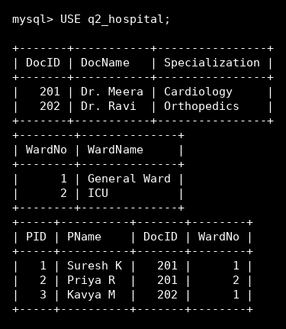

Question 3
University enrollment - Analyze FDs and apply 2NF
Marks: 5

Given Relation
Enrollment(SID, SName, CourseID, CourseName, Faculty, Grade)

Step 1 - Functional Dependencies Identified
- SID -> SName
- CourseID -> CourseName, Faculty
- (SID, CourseID) -> Grade

Candidate Key
Candidate key = (SID, CourseID), since a student enrolls in many courses and a course has many students; Grade depends on the combination.

Anomalies in the Given Relation
- Redundancy: a student's name is repeated once per course they enroll in.
- Update anomaly: correcting a course's faculty name means updating it in every enrolled student's row.
- Deletion anomaly: removing the last enrollment of a course erases that course's name and faculty entirely.

Step 2 - Normalization
1NF
All attribute values are atomic, so the relation is in 1NF.
2NF
SName depends only on SID (part of the key) and CourseName/Faculty depend only on CourseID (part of the key) - both are partial dependencies on the composite key.
Split the partially dependent attributes into their own relations, leaving only the fully key-dependent attribute (Grade) in the linking relation.

Final Normalized Schema
Student(SID, SName)
Course(CourseID, CourseName, Faculty)
Enrollment(SID, CourseID, Grade) -- FK SID -> Student, FK CourseID -> Course

SQL Output (executed result)
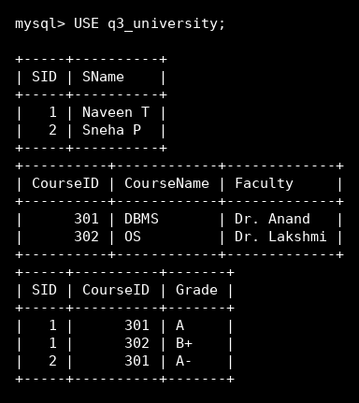
Question 4
Airline booking - Normalize Booking to BCNF
Marks: 5

Given Relation
Booking(FlightNo, PassID, PassName, Seat, DeptCity, ArrCity, Date)

Step 1 - Functional Dependencies Identified
- FlightNo -> DeptCity, ArrCity
- PassID -> PassName
- (FlightNo, Date, PassID) -> Seat

Candidate Key
Candidate key = (FlightNo, Date, PassID), since the same flight number flies on many dates and carries many passengers, each assigned one seat per specific flight instance.

Anomalies in the Given Relation
- Insertion anomaly: a new flight route cannot be stored until at least one passenger books it.
- Update anomaly: changing a flight's arrival city means updating it on every booking row for that flight.
- Deletion anomaly: cancelling the only booking on a date removes the flight's route information.

Step 2 - Normalization
1NF - 3NF
All attributes are atomic; the relation reaches 3NF but still has non-key determinants.
BCNF check
FlightNo -> DeptCity, ArrCity: FlightNo alone is not a candidate key (the key needs Date and PassID too) - violates BCNF.
PassID -> PassName: PassID alone is not a candidate key - violates BCNF.
Decompose to isolate both violating dependencies.

Final Normalized Schema
Flight(FlightNo, DeptCity, ArrCity)
Passenger(PassID, PassName)
Booking(FlightNo, Date, PassID, Seat) -- FK FlightNo -> Flight, FK PassID -> Passenger

Justification
In Booking, the only remaining FD is (FlightNo, Date, PassID) -> Seat, and the left side is exactly the candidate key, so BCNF is satisfied. Flight and Passenger are trivially in BCNF (single-attribute keys).

SQL Output (executed result)
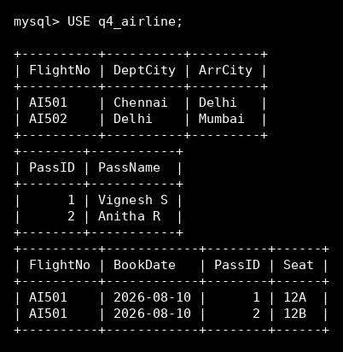
Question 5
Multinational HR system - Identify FDs/transitive dependencies, normalize to 3NF
Marks: 5

Given Relation
Employee(EmpID, EmpName, DeptID, DeptName, DeptLocation, Country, ManagerID, Salary)

Step 1 - Functional Dependencies Identified
- EmpID -> EmpName, DeptID, ManagerID, Salary
- DeptID -> DeptName, DeptLocation, Country
- Transitive dependency: EmpID -> DeptID -> DeptName, DeptLocation, Country

Candidate Key
Candidate key = EmpID.

Anomalies in the Given Relation
- Redundancy: department location and country repeat on every employee row in that department.
- Update anomaly: if a department relocates, every employee row for that department must be updated.
- Insertion anomaly: a newly opened department cannot be recorded until an employee is hired into it.

Step 2 - Normalization
1NF - 2NF
All attributes are atomic and the key is a single attribute (EmpID), so partial dependency cannot occur - the relation is in 2NF.
3NF
DeptName, DeptLocation and Country depend on DeptID, which itself depends on EmpID - a transitive dependency, which 3NF disallows.
Remove the transitively dependent attributes into a separate Department relation.

Final Normalized Schema
Department(DeptID, DeptName, DeptLocation, Country)
Employee(EmpID, EmpName, DeptID, ManagerID, Salary) -- FK DeptID -> Department, FK ManagerID -> Employee (self-reference)

SQL Output (executed result)
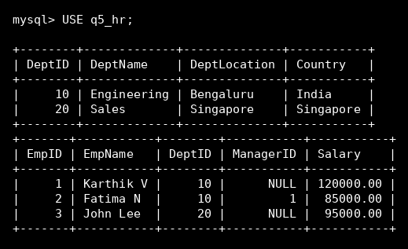

Question 6
Library system - Identify MVDs and decompose to 4NF

Given Relation
Library(MemberID, MemberName, BookID, Title, Author, Genre, BorrowDate)

Step 1 - Functional Dependencies Identified
- MemberID -> MemberName
- BookID -> Title
- Multi-valued dependency: BookID ->> Author (a book can have several authors, independent of genre)
- Multi-valued dependency: BookID ->> Genre (a book can belong to several genres, independent of author)

Candidate Key
The relation is already in BCNF with respect to functional dependencies (every determinant above is a candidate key fragment), but it still suffers redundancy because of the two independent multi-valued dependencies on BookID.

Anomalies in the Given Relation
- Redundancy: a book with 2 authors and 2 genres needs 4 rows to represent every author-genre combination, even though authors and genres are unrelated to each other.
- Insertion anomaly: adding one more genre for a book forces duplicating a row for every existing author.
- Deletion anomaly: removing one author's row can accidentally remove genre information if not handled carefully.

Step 2 - Normalization
Identify the MVDs
BookID ->> Author | Genre : for a fixed BookID, the set of Authors is independent of the set of Genres, which is the defining condition of a nontrivial multi-valued dependency.
4NF decomposition
Split the relation so each independent multi-valued fact gets its own relation, eliminating the need to store cross-product combinations.

Final Normalized Schema
Member(MemberID, MemberName)
Book(BookID, Title)
BookAuthor(BookID, Author)
BookGenre(BookID, Genre)
Borrow(MemberID, BookID, BorrowDate) -- FK MemberID -> Member, FK BookID -> Book

Justification
Each relation now has only trivial multi-valued dependencies (the key determines the whole tuple), which satisfies 4NF

SQL Output (executed result)
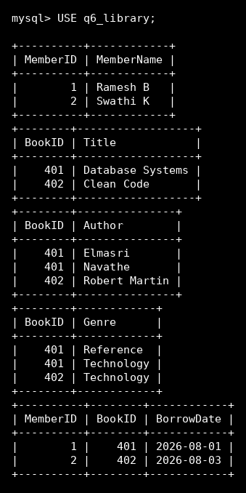
Question 7
Telecom billing - Identify candidate keys, primary key, and FDs before normalization

Given Relation
Bill(BillNo, CustID, CustName, PhoneNo, PlanID, PlanName, PlanCost, CallDate, Duration, Amount)

Step 1 - Functional Dependencies Identified
- BillNo -> CustID, PlanID, CallDate, Duration, Amount
- CustID -> CustName, PhoneNo
- PhoneNo -> CustID (phone number is also unique per customer)
- PlanID -> PlanName, PlanCost

Candidate Key
Candidate keys: {BillNo} and {PhoneNo, CallDate} (a phone number can only generate one bill per call date in this design). Primary key chosen: BillNo, since it is the simplest single-attribute key that determines every other attribute. PhoneNo is therefore a candidate/alternate key via CustID.

Anomalies in the Given Relation
- Redundancy: customer name and phone repeat on every bill row for that customer.
- Redundancy: plan name and cost repeat on every bill row that uses that plan.

Step 2 - Normalization
Normalize to 3NF (for completeness)
CustID -> CustName, PhoneNo is a transitive dependency through BillNo, and PlanID -> PlanName, PlanCost is transitive as well.
Remove both transitively dependent groups into their own relations.

Final Normalized Schema
Customer(CustID, CustName, PhoneNo)
Plan(PlanID, PlanName, PlanCost)
Bill(BillNo, CustID, PlanID, CallDate, Duration, Amount) -- FK CustID -> Customer, FK PlanID -> Plan

SQL Output (executed result)
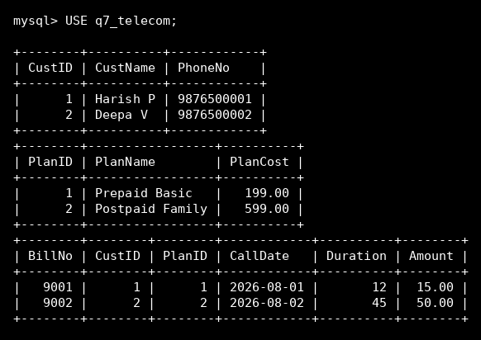

Question 8
Retail inventory - Apply complete normalization to Product

Given Relation
Product(PID, PName, SupplierID, SupplierName, Category, Price, Warehouse)

Step 1 - Functional Dependencies Identified
- PID -> PName, SupplierID, Category, Price, Warehouse
- SupplierID -> SupplierName

Candidate Key
Candidate key = PID.

Anomalies in the Given Relation
- Redundancy: the supplier's name is repeated on every product row supplied by that supplier.
- Update anomaly: a supplier's name change must be updated across every one of its products.
- Insertion anomaly: a new supplier cannot be added to the database until it supplies at least one product.

Step 2 - Normalization
1NF - 2NF
The key is a single attribute (PID), so no partial dependency can exist - the relation is already in 2NF.
3NF / BCNF
SupplierID -> SupplierName is a transitive dependency (PID -> SupplierID -> SupplierName), which violates 3NF.
Remove it into its own Supplier relation.

Final Normalized Schema
Supplier(SupplierID, SupplierName)
Product(PID, PName, SupplierID, Category, Price, Warehouse) -- FK SupplierID -> Supplier

Justification
After decomposition every determinant (PID in Product, SupplierID in Supplier) is a candidate key, so the design satisfies both 3NF and BCNF - this is the complete normalization.

SQL Output (executed result)
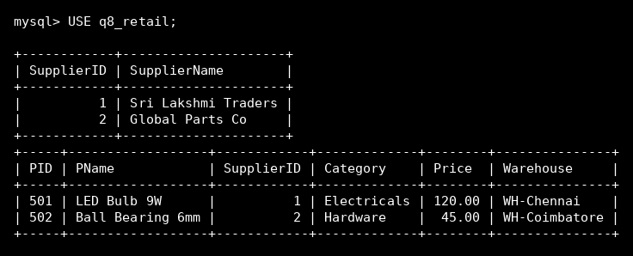
Question 9
School ERP - Propose a fully normalized design up to BCNF with justification
Marks: 5

Given Relation
SchoolERP(StudentID, StudentName, ClassID, ClassName, TeacherID, TeacherName, Subject, Marks, ParentName, ParentContact)

Step 1 - Functional Dependencies Identified
- StudentID -> StudentName, ClassID, ParentName, ParentContact
- ClassID -> ClassName
- (ClassID, Subject) -> TeacherID
- TeacherID -> TeacherName
- (StudentID, Subject) -> Marks

Candidate Key
No single attribute or the original combination determines every column at once - the schema as given is a poorly-designed, over-wide relation combining three separate real-world entities (student, class/subject/teacher assignment, and marks).

Anomalies in the Given Relation
- Redundancy: class name repeats for every student in that class, and teacher name repeats for every student they teach.
- Update anomaly: reassigning a teacher to a class-subject requires updating it on every affected student's row.
- Insertion anomaly: a new class-subject-teacher assignment cannot be recorded until a student is enrolled and scored.
- Deletion anomaly: removing a student's only mark row can wipe out the class-subject-teacher assignment if it existed nowhere else.

Step 2 - Normalization
Decompose by dependency group
Group 1 (StudentID -> ...): student's own attributes go into Student.
Group 2 (ClassID -> ClassName): class attributes go into Class.
Group 3 (TeacherID -> TeacherName): teacher attributes go into Teacher.
Group 4 ((ClassID, Subject) -> TeacherID): the class-subject-teacher assignment becomes its own relation.
Group 5 ((StudentID, Subject) -> Marks): marks become their own relation.

Final Normalized Schema
Class(ClassID, ClassName)
Teacher(TeacherID, TeacherName)
Student(StudentID, StudentName, ClassID, ParentName, ParentContact) -- FK ClassID -> Class
ClassSubjectTeacher(ClassID, Subject, TeacherID) -- FK ClassID -> Class, FK TeacherID -> Teacher
Marks(StudentID, Subject, Marks) -- FK StudentID -> Student

Justification
Every determinant in the five relations above (StudentID, ClassID, TeacherID, (ClassID,Subject), (StudentID,Subject)) is exactly the primary key of its own relation, with no attribute left partially or transitively dependent - this satisfies BCNF

SQL Output (executed result)
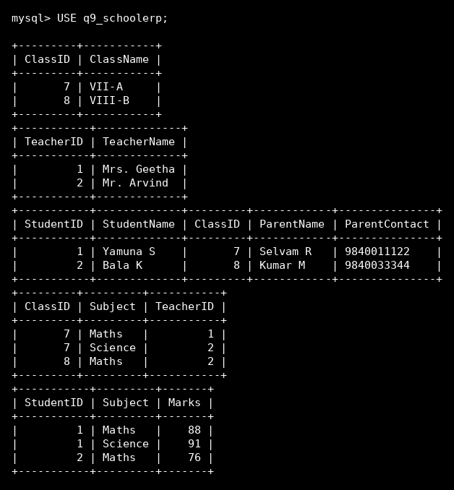
Question 10
Movie streaming platform - Identify join dependency, decompose to 5NF with lossless-join verification

Given Relation
Streaming(Movie, Actor, Platform)

Step 1 - Functional Dependencies Identified
- No single functional dependency holds among Movie, Actor, and Platform - the relation is already all-key and in BCNF with respect to FDs.
- Business rule (join dependency): whenever (Movie,Actor) is a valid pairing, (Actor,Platform) is a valid pairing, and (Movie,Platform) is a valid pairing simultaneously, then (Movie,Actor,Platform) must be a valid combination.

Candidate Key
Candidate key = (Movie, Actor, Platform) - the whole relation, since no proper subset determines the rest.

Anomalies in the Given Relation
- Redundancy: storing all three attributes together forces repeating rows for every valid movie-actor-platform triple, even though the constraint is really three independent binary relationships.
- Update anomaly: adding a new platform for an actor who appears in several movies means inserting one new row per movie that actor appears in.

Step 2 - Normalization
Identify the join dependency (JD)
JD = *( (Movie,Actor), (Actor,Platform), (Movie,Platform) )
This says the relation can be losslessly reconstructed from these three binary projections - a classic candidate for 5NF decomposition (the same pattern as the textbook Supplier-Part-Project example).
Decompose to 5NF
Project the relation onto the three pairwise binary relations named by the JD.
Lossless-join verification
Sample data: MovieActor = {(M1,Nayanthara), (M1,VijaySethupathi)}; ActorPlatform = {(Nayanthara,Netflix), (Nayanthara,PrimeVideo), (VijaySethupathi,Netflix)}; MoviePlatform = {(M1,Netflix), (M1,PrimeVideo)}.
Natural-joining all three back together yields exactly: (M1,Nayanthara,Netflix), (M1,Nayanthara,PrimeVideo), (M1,VijaySethupathi,Netflix).
(M1, VijaySethupathi, PrimeVideo) is correctly NOT produced, because (VijaySethupathi, PrimeVideo) is absent from ActorPlatform - so the 3-way join reproduces only genuine facts with no spurious tuples, confirming the decomposition is lossless and the design satisfies 5NF.

Final Normalized Schema
MovieActor(Movie, Actor)
ActorPlatform(Actor, Platform)
MoviePlatform(Movie, Platform)

SQL Output (executed result)
